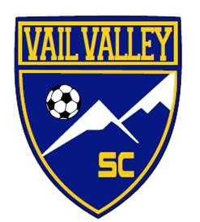

Vail Valley Soccer Club Scholarship Application
Fall Competitive applications must be submitted by May 31, 2018
Fall Recreational applications must be submitted by May 31, 2018
High School boys applications must be submitted by December 1, 2018
All information must be completed in order to be considered for assistance from the Vail Valley Soccer Club. No scholarships will be considered or granted if there are outstanding balance on player accounts. Please be aware that families receiving assistance will be required to sell all their assigned VVSC Raffle tickets and complete all volunteer hours.
If you feel you require more financial assistance than is available, please contact director@vailsoccer.com for job opportunities. There is a new program to ex- change fees for employment.
Employment exchange opportunities include:
Volunteer Coordinator Fall
Volunteer Coordinator Spring Referees
Volunteer Coordinator Vail Cup
Registrar Assistant
Raffle Coordinator
Fundraising Chair

Applicant’s Name:_____________________________________________________
Address:____________________________________________________
Town:______________________________ State:_________________ Zip: _____________
Home/Cell Phone #_____________ Work Phone #____________________
Email Address:____________________________________________________
Child(ren)’s Name(s):
Name:___________________________Date of Birth____/____/____
Name:___________________________Date of Birth____/____/____
Name:___________________________Date of Birth____/____/____
Name:___________________________Date of Birth____/____/____
Name:___________________________Date of Birth____/____/____

QUALIFICATIONS FOR VVSC SCHOLARSHIPS: Families living in Eagle County that currently qualify for the school lunch program qualify to apply for financial assistance with the Vail Valley Soccer Club for player fees, uniform costs and travel expenses.
- Families qualified for reduced price lunches receive 50% discount on player registration fees and tournament fees.
- Families qualified for free lunches receive a 75% discount on player registration fees and tournament fees.
  - Please provide a copy of the school’s district’s lunch program approval letter.

